Installing all the Packages and testing Swagger and ValuesController.

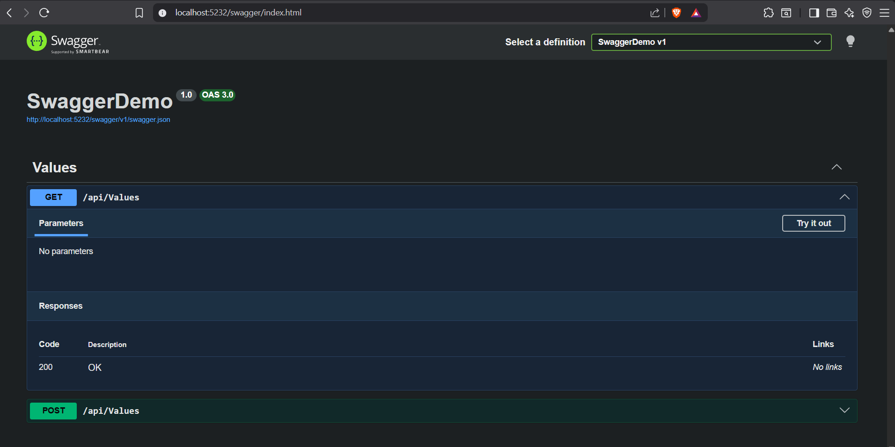

Testing Employee Controller using Postman
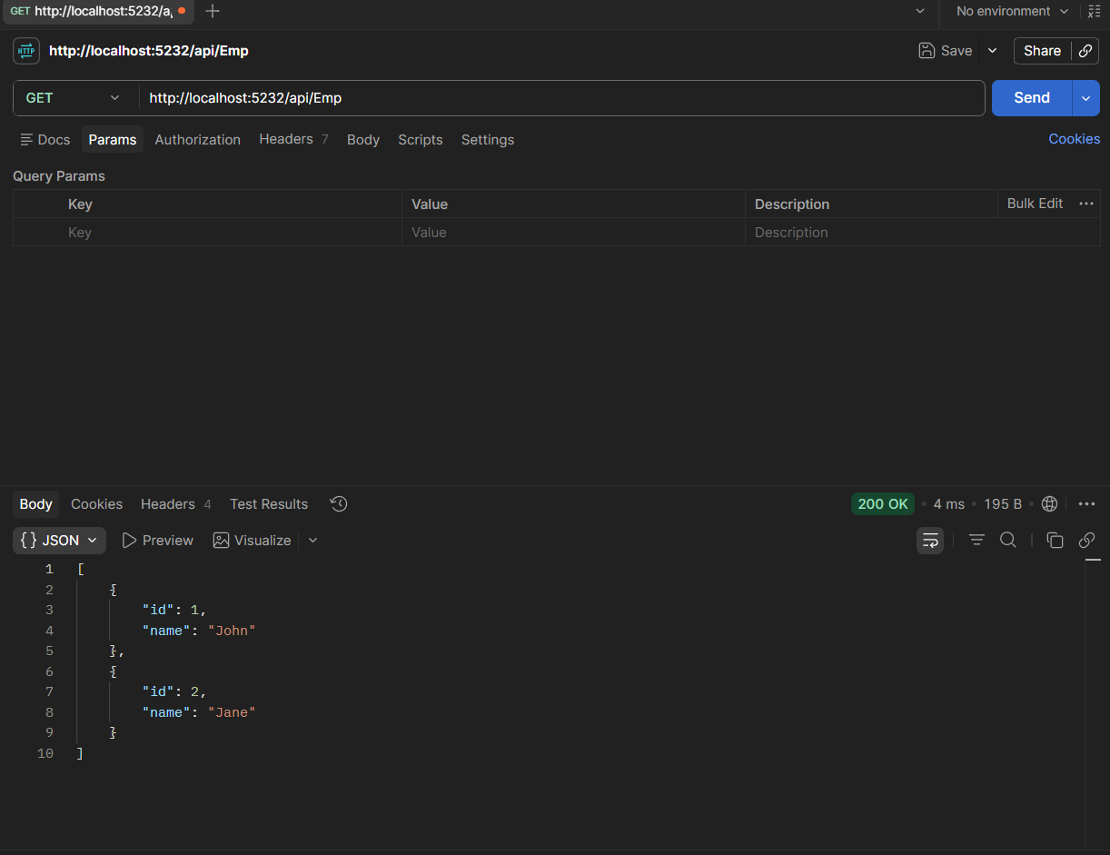

Modifying the route to emp 